INTEL: THE ‘COPY EXACTLY’ POLICY
As Mark McLean, senior architect with IDC, arrived to his office desk at the headquarters of the engineering and project management consultant in Portland, Oregon, USA, he looked troubled. It was June 30, 2000, about 10 years since Mark had first became involved in designing semiconductor fabrication facilities (‘fabs’). He had recently been promoted to design manager: his responsibilities included co-ordinating a team of lead architects and engineers, as well as liaising with the project clients. At 2pm, Mark was leading a conference call with IDC and Intel representatives. He wanted Intel to submit a priced change order instructing IDC to implement a request to change the design solution of the F22 Fab.

The design for this new fab in Chandler, Arizona, code-named F22, was an ‘exact copy’ of the as-built drawings of another fab, code-named D1C. The shell of the D1C was already built in Hillsboro, Oregon, two years ago, and the fab was now being tooled. The first changes affecting the F22 design dated back to the early design stages in March 2000 when Intel requested various alterations to the D1C as-built drawings. These included additional rooms, different uses for existing rooms (and accordingly different design criteria), and a new centralised waste management system. A few weeks later, Intel and IDC generated the corresponding priced change order which the Intel Change Control Board approved in April 2000. IDC designers then tacitly assumed that other design criteria and planned uses for other rooms would remain unaltered. Construction for the F22 base-build structure started in June, while designers developed its fit-out design. To design the fit-out of the “Hazardous Waste Storage Solvent Room” (solvent room), designers assumed that small quantities of corrosive chemicals would be brought in and stored in small bottles. These bottles would be taken into an adjacent room where they would be open poured ^{(*)} into 50 gal drums; the drums would be moved to the hazardous material dock. Mark had learnt two weeks ago, however, that Bruce Southern ⎯ the solvent room ‘owner’ recently appointed by Intel ⎯ was planning to do open pouring in the solvent room and accordingly the fit-out design needed to change.

While Mark was used to handling late end-user requests to change the design, this one was special. The type and maximum quantities of chemicals stored in a room, as well as the usage conditions (open vs. close pouring), determined the room classification according to the applicable Building Code (Exhibit 1) and Electrical Code Handbook (Exhibit 2). A reclassification of the solvent room could significantly impact the design solution. Mark knew that some assumptions made by IDC designers, such as assuming that no open pouring would take place in the solvent room, were not documented. He considered nonetheless that there were valid reasons explaining why those assumptions had not been written down. To prepare for the 2pm conference call, Mark decided to meticulously review the design change history.

(*) Open pouring is a manual operation to dispose a chemical by flowing it in a continuous stream from one bottle into another bottle or a large drum; this operation is termed close pouring if it takes place inside an exhausted closure, e.g. an exhausted stainless steel enclosed cabinet
Background
Intel was the world’s largest semiconductor manufacturer, with circa 10 semiconductor fabrication facilities (‘fabs’) and 6 assembly and test facilities spread around the world. It had been founded in 1968 to build semiconductor memory products, developing the world's first microprocessor in 1971. In 2000, it was a publicly listed company that employed 78,000 people worldwide and ranked 65th in the Fortune 500. It supplied the computing and communications industries with chips, boards, systems, and software building blocks. Intel had plans to spend $3.5 billion on capital investments to build manufacturing capacity and increase manufacturing efficiency and spend almost $4 billion on R&D. Just for the second quarter of 2000, Intel had announced revenues of $8.3 billion, a new quarterly record, up 23% from the second quarter of 1999 and up 4% sequential.

Unlike Intel, Industrial Design Corporation (IDC) was an employee-owned leading supplier of facility planning, design, construction, and ongoing support services for process-intensive technology industries. IDC had been established in 1974 by its parent company CH2M HILL to mainly serve private industry clients. IDC workforce included architects, engineers (e.g., structural, mechanical, chemical, electrical, and industrial), design-, construction-, and project managers. It had received the 1997, 98, and 99 Top Fab Award presented by Semiconductor International, a magazine specialising in the semiconductor industry. IDC had long nurtured a close relationship with Intel, for whom it had developed several generations of fabs. In June 2000, IDC was vigorously recovering from a lengthy downturn in fab design work that had forced it to let go some of its best skilled staff.

Fabs were large-scale facilities commissioned by chipmakers to house the tools necessary for the production of wafers, i.e., silicon-based discs on which the semiconductors⎯the basic building blocks of integrated circuits or chips⎯were etched. Wafers were then sent to assembly and test facilities where they were cut into individual microprocessors, placed within external packages, and tested for functionality. Fabs were technologically complex and costly high-tech facilities because production of silicon wafers was a complex manufacturing process that involved various state-of-the-art, expensive tools. These tools, developed by different suppliers located around the world, hooked up to a large number of mechanical, electrical, and chemical systems as well as to support equipment (Exhibit 3). Tools required steady utility flows and stringent environmental conditions to operate; they could change significantly between generations of chip manufacturing technology, e.g., in weight and size, in number and type of utility hook-ups, and in number and size of needed support equipment.

In 2000, chipmakers worldwide, including Intel, were looking for solutions to reduce the duration of new fab development projects (including design, construction, and tooling) to less than 18 months. They also looked to reduce the fab construction time (defined as the number of months from the first concrete pour to when the first piece of manufacturing equipment is ready for qualification) to less than 11 months; and to reduce the time elapsed from the first concrete pour to the first full output of wafers to less than 16 months. Further, they aimed to reduce the construction time to less than 9.5 months by 2014. These were important goals for Intel because the profitability of its capital projects was contingent on project speed: if Intel reached the market first with a new product it could benefit from higher-priced sales and pre-empt competitors. In 2000, a fab project represented a capital investment in the order of $2bn: one billion in tools and another billion divided in two approximately equal shares — constructing the fab building and installing the tools inside.

Intel fab projects included 6 main phases:
- Programming: definition of fab requirements, including products to manufacture, average number of wafers to produce monthly, and preliminary list of tools; these requirements were converted into design criteria using rules of thumb and historical data.
- Design: design of the building shell systems (e.g., civils, structural, exterior cladding, roof) and of the building core systems (e.g., mechanical, electrical, chemical, life safety, telecom, instrumentation & controls, interior partitions).
- ’Base-build’: array of operations including preparing and excavating the site, building foundations, erecting the steel/concrete superstructure, and installing the exterior cladding and roof of the fab building.
- ‘Fit-out’: installation of the main and lateral utility routings in the subfab (e.g., electrical cabling, pipes, Heating & Ventilating Air Conditioning [HVAC] ducts) and of walls, floors, and ceiling systems in the fab cleanroom.
- ‘Tooling’: design of the tool-install systems, and installation of the cleanroom tools and of the subfab support equipment (e.g., vacuum pumps, heat exchangers, and gas cabinets).
- ‘Ramp-up’: increase of the factory production up to the target production rates while fine-tuning the manufacturing processes.

A challenge in managing the fab development projects was Intel’s practice of overlapping the six phases for accelerating delivery (Exhibit 4). For each building system delivery, Intel typically overlapped design, manufacturing, and construction phases. Across systems, it overlapped the design of the fit-out systems with the construction of the base-build systems. Further, it overlapped fab fit-out work and tooling work, and within tooling, it overlapped the design of the tool-install systems with the tool installation work on site.

Another managerial challenge stemmed from uncertainty in design criteria caused by unpredictable events outside the design-construction-tooling environment. Each event could cause a stream of late requests to change design criteria over the project time, known as “design change orders.” There were three main sources of external uncertainty: The first was technological innovation. Intel fabs were either for technology development (TD) or for high-volume manufacturing (HVM). TD fabs housed pilot lines of new tools for research and development (R&D) of new chip manufacturing processes. Breakthrough innovations in R&D and/or in tooling technology were likely to affect the fab design criteria and impact the fab design-construction-tooling process. In contrast, fewer external events were likely to affect a HVM fab project because its lines of tools had already been fine-tuned in a D1C fab. The delivery of a HVM fab could nonetheless be affected by external events especially when it unfolded concurrently with the delivery of a TD fab.

A second source of uncertainty related to unforeseen modifications in the forecasts of market demand for chips. Pronounced swings could force Intel to change the project anticipated due dates or the planned production capacity, which in turn could affect the cleanroom area design requirements or the number and type of tools to install in the cleanroom. The third source of uncertainty related to end-user participation in the late design stages, when Intel started to recruit operating staff and allocating ownership of fab spaces and equipment. ‘Room owners’ were likely to request late changes to the fit-out design to align the space configurations with their working methods.

Intel’s ‘Copy Exactly Technology Transfer Method’
Intel had limited understanding of how seemingly tiny design details influenced production yields and chip quality. This was due, first, to the numerous factors involved in chip manufacturing and fab design; and second, to the complex technical interdependencies between fab systems and process flows. Design complexity had increased with each technology generation. In the 1990s, in reaction to the Intel–U ⎯ a drop in factory yields every time a new technology or product was developed in a TD fab and transferred to a HVM fab ⎯Intel instituted the “Copy Exactly Technology Transfer Method” (Exhibit 5).

The method stated in its simplest form that “everything that could affect the process, or how it was run, ought to be copied down to the finest detail unless it was either impossible to do so or there was an overwhelming competitive benefit to introducing a change.” It recommended, first, to match all physical inputs supplied by external sources (e.g., gas flows, temperatures, pressures, and RF power) between TD and HVM lines. Second, it recommended to “copying exactly everything about equipment and its installation down to diameters of piping and the number of bends, board revisions, and software.” To support these recommendations, Intel developed a system for controlling all physical changes in a new fab or on a new process flow in an existing fab. To get a change approved, the project manager had to submit an audit report, code-named ‘white-paper’, to the Intel Change Control Board. The Board was ultimately responsible for ensuring that the new requirements did not slow the rate of technology transfer. Each white paper had to describe the change impacts and costs, assess the risks, and develop alternative action plans.

Intel attributed to the Copy Exactly policy its ability to speed up technology transfer from a TD into a HVM fab, while sustaining the production yields of the TD fab. Copy Exactly had reportedly brought Intel major benefits in product reliability irrespective of the source fab, in flexibility to transfer products between fabs if need be, and in sharing improvements between fabs. It also enabled staff to move across fabs around the world which could be important if an extreme event knocked down fab operations in one part of the world, and another fab was then asked to swiftly pick up production to meet global demand. The Copy Exactly policy did not apply to TD fab development projects neither to match TD and HVM fab design features that had no impact on the chip manufacturing process. Rather, Intel encouraged tool and fab suppliers to pursue new ideas in the design of new TD fabs. Changes to fab design had however to be introduced first into the TD fab and from there transferred to the HVM fab.

Business Environment
In 2000, the semiconductor industry was emerging from a long recession, which started in 1996 when the Asian financial crisis triggered a downturn in the market demand for chips. The downturn left chip manufacturers with too much production capacity and decimated their expansion plans; most manufacturers also postponed their plans to deploy 300mm-wafers in 1998 (Exhibit 6). In 1999, Intel foresaw a recovery and decided to reactivate its capital program. Gordon Moore, Intel’s chairman emeritus, described the deployment of 300mm-wafers as “the largest industrial retooling in history.” Semantech, an industry consortium, estimated the cost of the tool shift from €14 billion to €30 billion (2000 prices).

Hence, in 1999, Intel announced to Wall Street analysts that it was taking the lead in the production shift by starting to upgrade D1C, a research factory in Hillsboro, Ore. D1C would be the first fab worldwide to handle 300mm-wafer equipment as well as the new copper-based technology to make 0.13-micron line circuits — a move estimated to cost $1.2 billion. Intel further said that expected D1C to begin deploying wafers in early 2000 and that once the process would be refined, it would roll out volume production at its other fabs in 2002. On Jan. 25, 2000, Intel announced the start of development for F22, Chandler, Ariz., the first HVM fab worldwide for 300mm-wafers—a $2 billion investment. Mike Splinter, Intel senior vice president and general manager of the Technology and Manufacturing Group, said:

“This facility will help us maintain our leadership in the extremely competitive world of semiconductors. F22 will give us more manufacturing capacity in order to help us better address our customers’ growing need for high-performance microprocessors. Intel plans to bring this fab on line in record time to meet our customers’ needs.”

In June 2000, Intel announced the start of development for F24, Dublin, Ireland. F24 was expected to begin production using 0.13-micron process technology with copper metallization in 2001—another $2 billion investment. Intel awarded to IDC the leadership in designing the three projects: D1C, F22, and F24.

While tool suppliers, such as Applied Materials, AMAT, Hitashi, KLA Tencor Corp., Tokio Electron (TEL), Nikon, and Hitachi, started to deploy the first 300mm-wafer tools for installation at the D1C fab (around 150 major tools were expected to arrive at D1C between November 1999 and October 2000), Intel and IDC were learning on first-hand about the differences between the new 300mm-wafer and the ‘old’ 200mm-wafer tools. These differences consisted of increased height and footprint dimensions, increased weight, disproportionate increases in the requirements of the subfab area for support equipment, and increased utility consumptions (including electrical, exhaust, process cooling water, and ultra-pure water). Further, the size and weight of the wafer carriers (called Front Open Unified Pods or FOUPs) were likely to exceed the health and safety upper limits above which cleanroom staff was prohibited from manually handling the FOUPs; 300-mm wafers were also expected to be more sensitive to shock and vibrations. To accommodate the latter requirements, Intel was implementing an automated material handling system (AMHS) at the D1C fab to move the FOUPs between tools and automated stockers. Intel and IDC teams were, however, not clear on the full range of design modifications demanded by the new tools. In particular, they were unclear about the extent to which key parameters in the D1C fab base-build design, such as cleanroom ceiling height, aisle width, and subfab space, would suit the design requirements imposed by the 300mm-wafer and automated equipment.

History of the Design Change Order
The F22 fab design was an ‘exact copy’ of the as-built drawings of the D1C fab. The D1C fab was already being tooled when IDC started the F22 fab design. Intel requested the first modifications to the F22 fab design in February/March 2000, including additional rooms, different uses for existing rooms (and accordingly different design criteria), and a new centralised waste management system (Exhibit 7). A few weeks later, IDC’s design team generated the corresponding priced change order. Intel approved this order in April 2000. IDC designers then assumed that other design criteria and rooms uses would not change.

Construction of the F22 base-build structure started while IDC’s designers were developing its fit-out design in June 2000. Designers reused the ‘as-built’ fit-out drawings of the D1C “Hazardous Waste Storage Solvent Room” (solvent room), which assumed that limited quantities of disposable chemicals would be brought in and open poured into small bottles over a chemical lab-type bench with sinks topped with a ventilating hood. These bottles would be stored in the solvent room and then taken out to another room, adjacent to the solvent room and to the hazardous material dock, where they would be open poured into 50 gallon drums. Open pouring inside the solvent room would therefore be in very limited quantities. This operating scenario fit with the conditions in the two national codes for a location defined as Class I, Division 2.

In the first week of June, Mark received a call from Intel’s prospective room-owner for the solvent room⎯Bruce Southern. Bruce wanted to check as to whether the solvent room fit-out design allowed for open pouring of disposable chemicals into 50 gallon drums. Bruce disliked transporting bottles with hazardous materials to a room adjacent to the hazardous material dock to dispose of the contents into larger drums. This usage regime did not fit with the new waste management philosophy that was planned in for the F22 fab. To accommodate Bruce’s request, IDC would have to possibly reclassify the room as a Class I, Division 1. This change could significantly impact the fit-out design, including:
- Redesign the electrical installation to be spark-proof (e.g., seal equipment and conceal motors and light switches);
- Design stringent fire safety and telecom systems;
- Design a special drain management system to accommodate water flowing from fire sprinklers (e.g., set of trenches and low point sinks);
- Redesign the Heating, Ventilating, and Air Conditioning (HVAC) system to increase ventilation rate capacity.

On June 15, the F22 Civil/Structural/Architectural (CSA) workgroup discussed the possible design changes for the solvent room in a conference call. The meeting agenda extended over 50 items, such as queries on requests for information, updates on construction progress, definitions of design solutions, agreements on design review dates, decisions on component suppliers, and discussions on lessons learned from D1C. The conference was attended by Mark representing IDC’s design team at Portland and by 6 Intel representatives located at Arizona. Intel’s team included Graham Smith, design manager; Helen Sasse, design layout co-ordinator; Michael Green, tool manager; and Ken Parker, construction manager. Intel had already submitted 22 major design change orders since the project started in January. The action for Intel was documented as follows:
“Hazard Waste Layout: Provide Hazards. Need meeting with room owner to verify chemical quantities. Michael Green will pursue. Hazard Waste Design due out to the contractor on 7/20/00. The hazardous waste storage area has a solvent room that is looking like a Class 1, Div. 1 space. Need to confirm chemical usage of room.”
Further, the action request log appended to the meeting minute noted:
Green: Confirm Haz. Waste chemical types and quantities for IDC code analysis.
Mark: Confirm chemical usage of Haz. Waste Stg. Room, before full design of Class 1, Div. 2 solvent room. This is a change from D1C’s as-built drawings. Need cross discipline understanding of use of space.”

On June 20, at 6.20 PM, Taha Moka, the IDC code analyst, emailed Liu Liu, the Intel room user, a summary of a telephone discussion they held on the same day (the email was copied to David Eccles, IDC chemical design lead):
“Here is a summary of our telephone discussion: The solvent room contains the following solvents… Can you provide the quantity of chemicals in that room, by classification if possible? It would be a significant advantage if the total quantity of Flammable 1B liquids is less than 30 gallons and total quantity of Combustible 2 liquids is less than 160 gallons.”

On June 21 at 1.20PM, Liu replied to Taha and copied to David:
“I’m still looking for the layout of the Hazwaste room but haven’t seen one. Once I get it, I’ll forward it to you. The following are the solvent systems that will be installed in the solvent room. I think the quantity of flammable and combustible chemical listed below in your e-mail message is for open container and since the solvent bottle wash sinks are relocated to the hazardous waste room and the above systems are considered closed systems, i.e., the solvents are contained inside the totes and delivered via Chemical Dispense Modules, these become irrelevant in your room classification evaluation, don’t they? Hope this helps.”
On the same day at 2.46 PM, Liu emailed again to Taha and copied to David:
“After our conversation, I realised I misunderstood your reference of the solvent room as the solvent CDM room not the solvent Hazwaste room. Anyway, I checked with my sustaining counterparts (chemical engineer and EHS rep) and confirmed that the aggregate of flammable fluctuates and can exceed 60 gals, and combustible is definitely in the 200 gals range. So I guess you know the answer. We’ll have to stick with the H1 occupancy for the Hazwaste room.”

On Friday, June 23 at 7.48 AM, Green emailed Mark informing that:
“Hope this is not too late... I talked with Vicky Susi regarding the Hazwaste storage area and here’s what I got: the area will contain corrosives and flammables in quantities of no more than 55 gallons at a time; chemical drums are shipped out every 90 days; typical quantities are 10-15 gallons; typical chemicals are ...; there is some open chemical pouring in the sinks. Hope it helps, let me know if you need more info.”

On Monday, June 26 at 11.43 AM, Mark forwarded Green’s email to Taha with the following note (Mark copied the email to Adam Tandjono, IDC architect):
“FYI. Taha, let’s add this info to the code analysis for the Haz Waste Stg. Room and make sure the code diagrams, occupancies, and electrical classifications are communicated to the other disciplines. Work with Adam to make sure we’re in sync with the code requirements. Thanks.”

On Friday morning, June 30, Mark sent a 25-page fax to Graham Smith:
“Progress design sketches on above noted subject [Haz. Waste Storage Design Change Notice] for today’s program validation meeting on room requirements. Please take additional copies to your meeting today for distribution. I’ve attached room data sheets for your room owners to document all room requirements, if helpful. Thanks.”

The fax included design drawings of the solvent room for the D1C and F22 fabs, copies of pages from the Building Code and the Electrical Code Handbook, a copy of recent e-mail exchanges, and blank copies of data sheets for the solvent waste room, corrosive waste room, corrosion control room, staging area, hazardous waste dock, and decontamination room.

Conference Call
After spending two hours reviewing the design change history, Mark mulled over two issues. First, he wondered if he had collated all the necessary information in the fax. Mark thought that to move forward Graham would need to develop a ‘white paper’ about the design change, and get it approved by the Intel Change Control Board. Mark also knew that he could not argue that the drawings were unreliable since everyone knew that late design changes often go undocumented in ‘as-built’ drawings. While Mark ignored if a similar change had taken place during the D1C fab design, he felt that his team did well in reusing the D1C ‘as-built’ drawings without validating the design assumptions. After all, this was exactly what Intel had asked IDC to do to speed up design development. Mark also wondered how much work was needed to implement the change. While he guessed that the change would not involve a lot of design rework for the architects, he was less sure of its impacts to other disciplines, especially if the room classification had to change. In particular, he was not sure if the design detailing packages for the different specialities had already been released to the contractor.

* * * * *
Mark had now 4 hours left before the conference call start at 2pm. He expected that at least two senior Intel people at Arizona would attend the call: Graham Smith, design manager and Bruce Southern, room ‘owner.’ At IDC’s Portland office, Mark had called Adam Tandjono, architect; Taha Moka, code analyst; and 5 design leads (chemical, mechanical, structural, electrical, and fire safety). While Mark sipped his coffee, he pondered over how to best use the time left: ask some more questions to the design leads? Ring his mate at the D1C fab to check out if a similar design change occurred during design fit-out? Visit the D1C fab (45-min drive) to find out how its solvent room was being used? Would he want to say anything about the Copy Exactly policy?
Exhibit 1 – 1997 Building Code
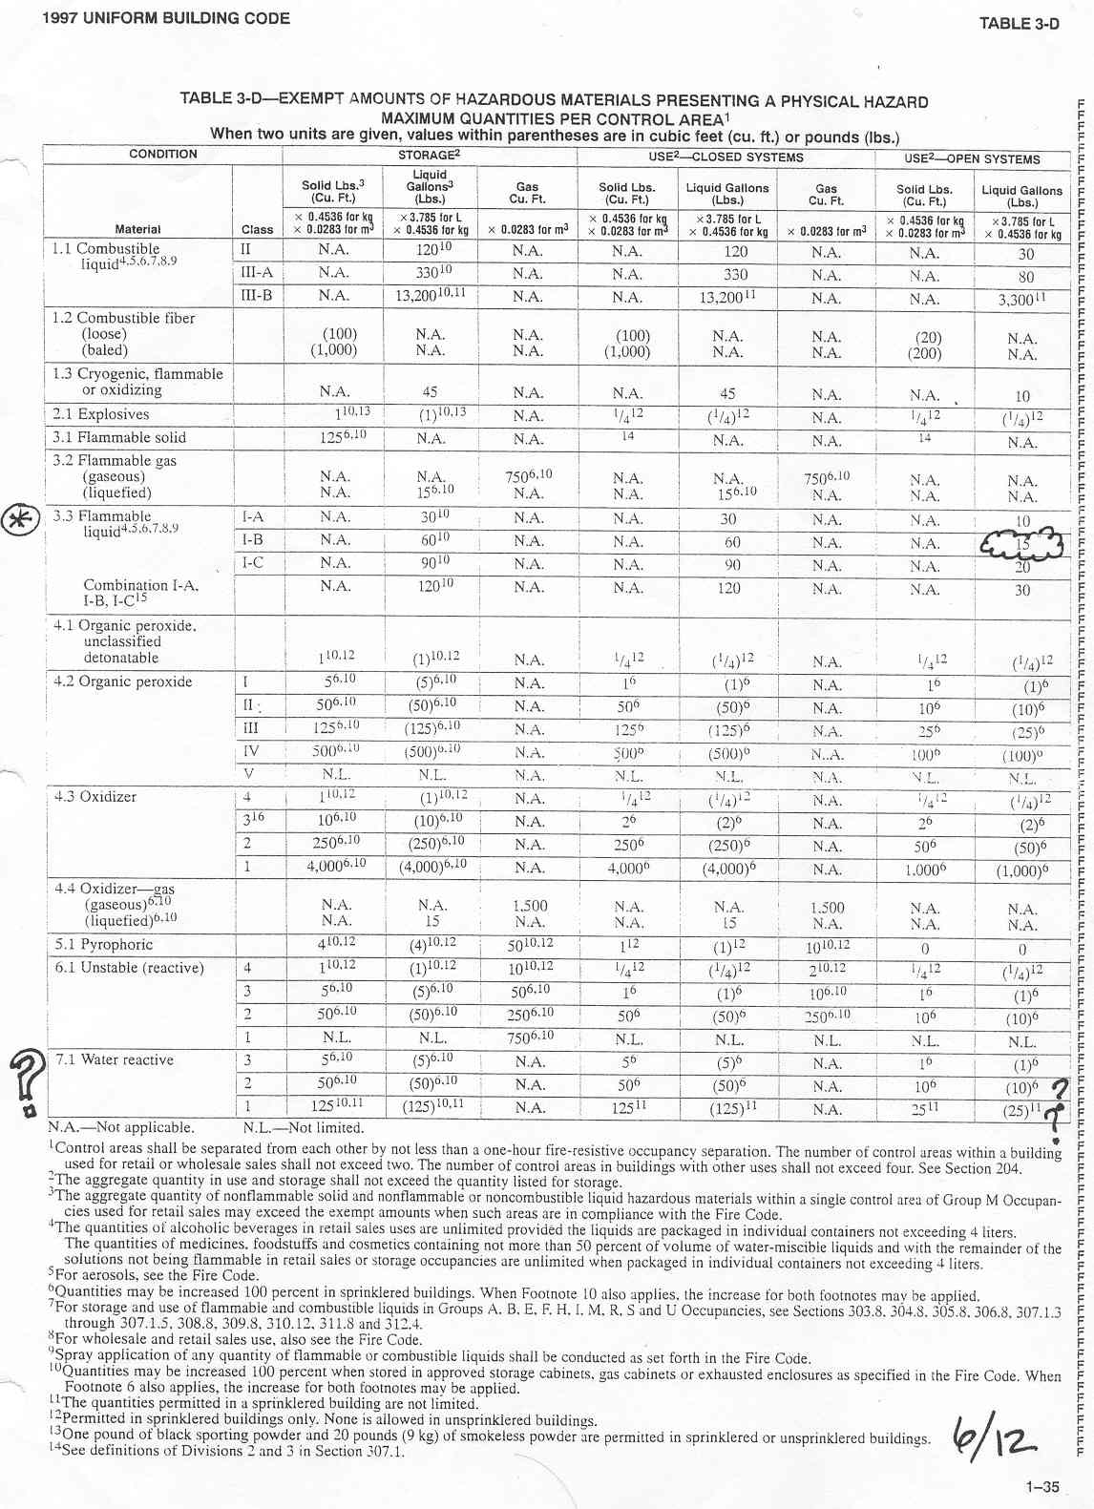

Exhibit 2 – 1999 Electrical Code
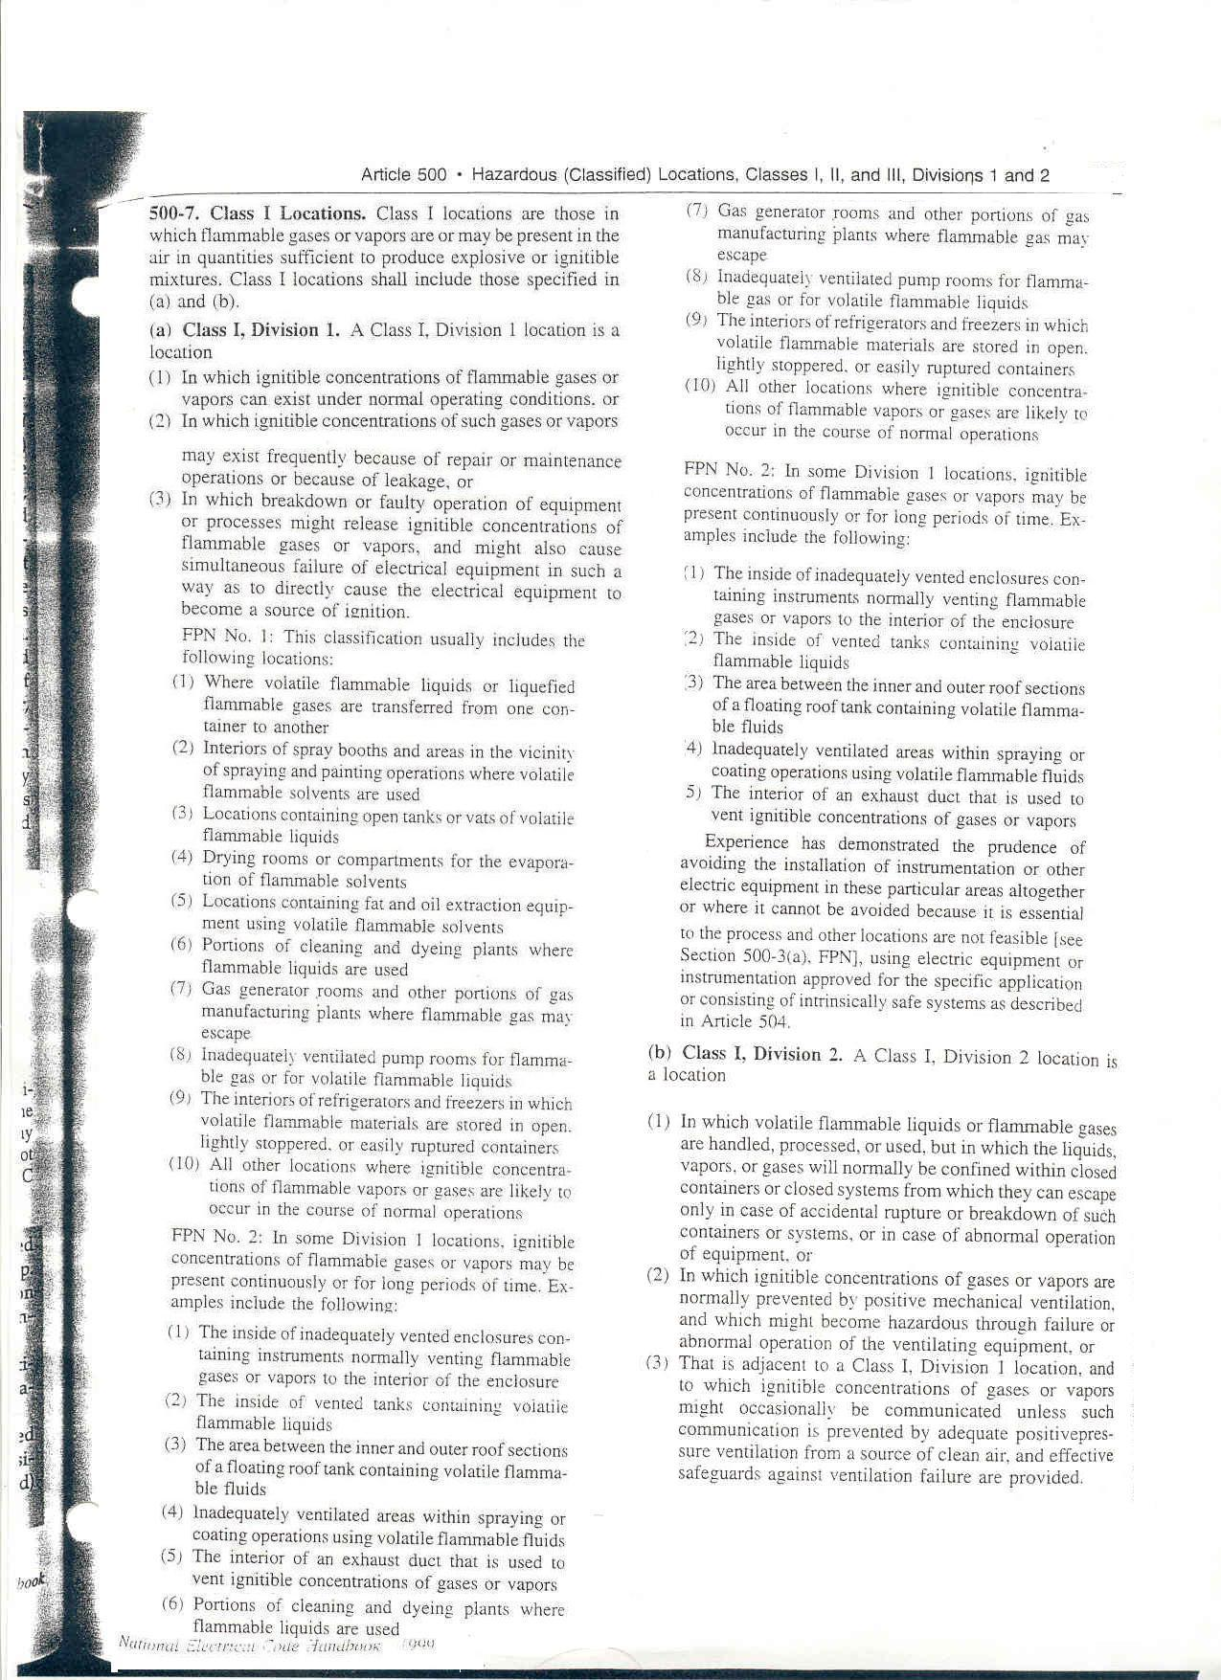
Exhibit 3 – Cut-away arrangement of a production tool set in a fab (Adapted from microKinetics, Inc.)

Fabs are large-scale high-tech facilities that house the tools necessary for the production of wafers, i.e. silicon-based discs on which the semiconductors ⎯ the basic building blocks of integrated circuits or chips ⎯ are etched. Wafers are then sent to assembly and test facilities where they are cut into individual microprocessors, placed within external packages, and tested for functionality. Fabs are technologically complex and costly facilities because manufacturing of silicon wafers involves various sophisticated, state-of-the-art tools. These tools, developed by suppliers located around the world, hook up to a large number of mechanical, electrical, and chemical utilities as well as to support equipment. Tools require steady utility flows and stringent environmental conditions to operate; they can change significantly between generations of chip manufacturing technology, e.g., in weight and size, in number and type of utility hook-ups, and in number and size of needed support equipment.

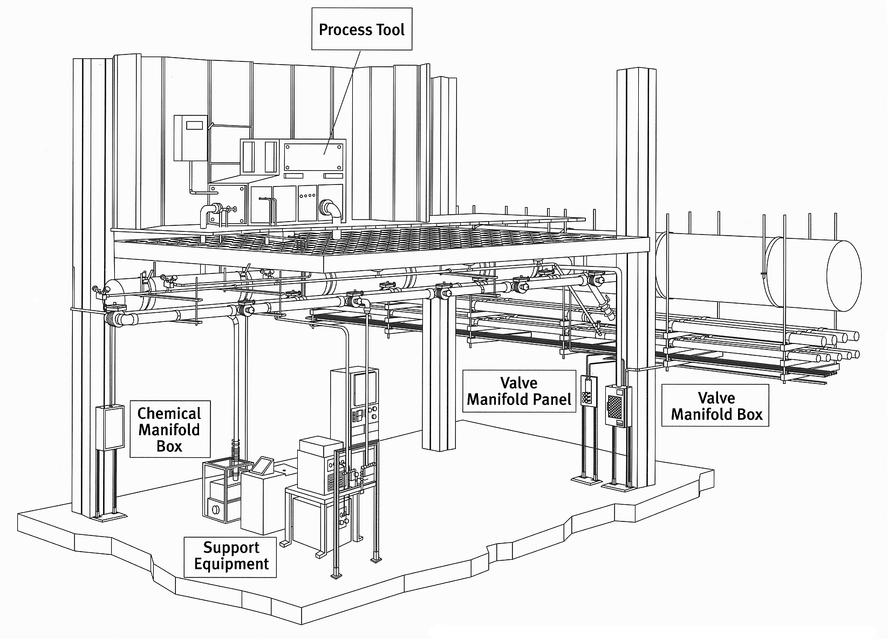

Cleanroom
Subfab

Main

Lateral

Cleanroom: space inside the fab where to locate the production tools, such as etchers, steppers, tracks, ashers, and planars.
Subfab: space under the cleanroom where to house: (1) utility routings (e.g., process piping, exhaust ductwork, electrical cables); (2) equipment to support the building systems, such as transformers, chillers, pumps, and boilers; and (3) equipment to support the tools, such as vacuum pumps, gas cabinets, temperature and humidity controls, air filters, and heat exchangers.
Tools: The number of major semiconductor tools to equip a fab easily reaches 150, including ashers, steppers, sputterers, copper electroplaters, polishers, scanners, trackers, and wafer inspection systems. These tools can all arrive within less than 8 to 10 months to the fab’s loading dock. They are manufactured by suppliers spread all over the word and transported by ship, aircraft, rail, and trucks. The average price of a tool can reach 4€ million, with the most expensive tools costing more than €10 million each (2000 prices).
Exhibit 4 –Intel Fab Development Programme
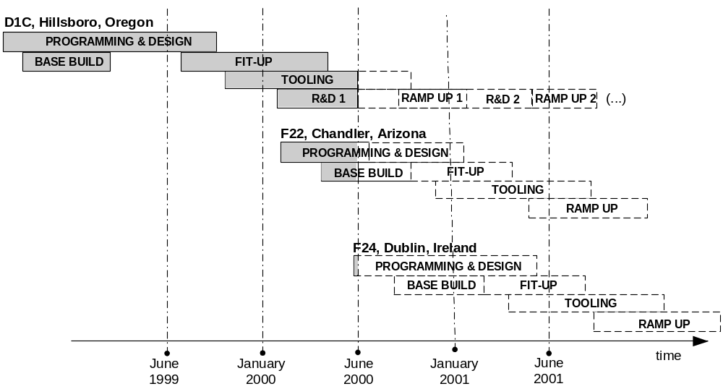
Exhibit 5 - Results of the Copy Exactly Technology Transfer Method for the 0.5-micron generation (McDonald 1998)

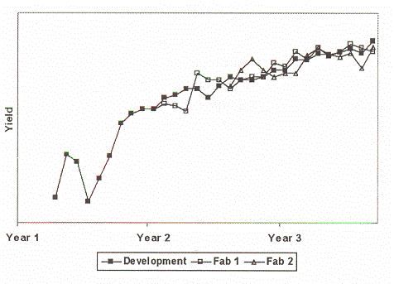

Exhibit 6 - Capital Spending on New Fab Projects Worldwide (Reprinted by permission of Strategic Marketing Associates)

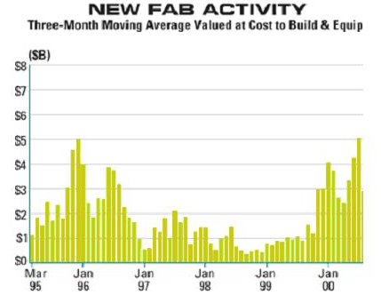

Exhibit 7 – Impact of Design Change Orders for one Copy Exactly HVM Fab
…
…
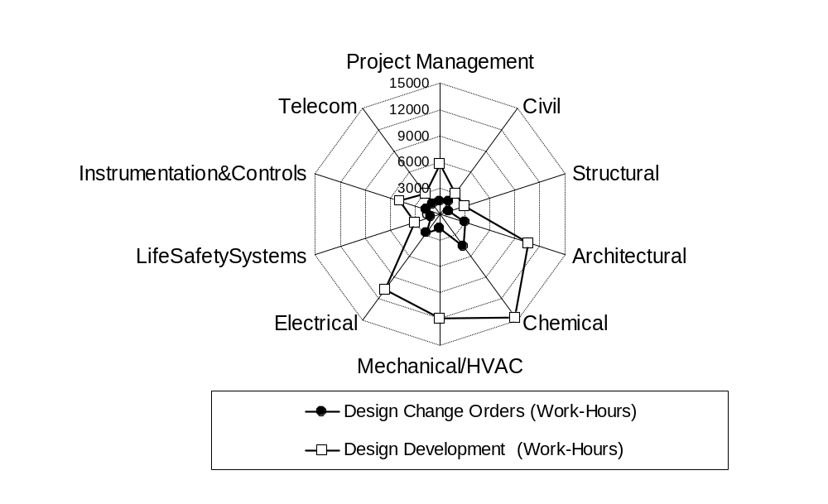

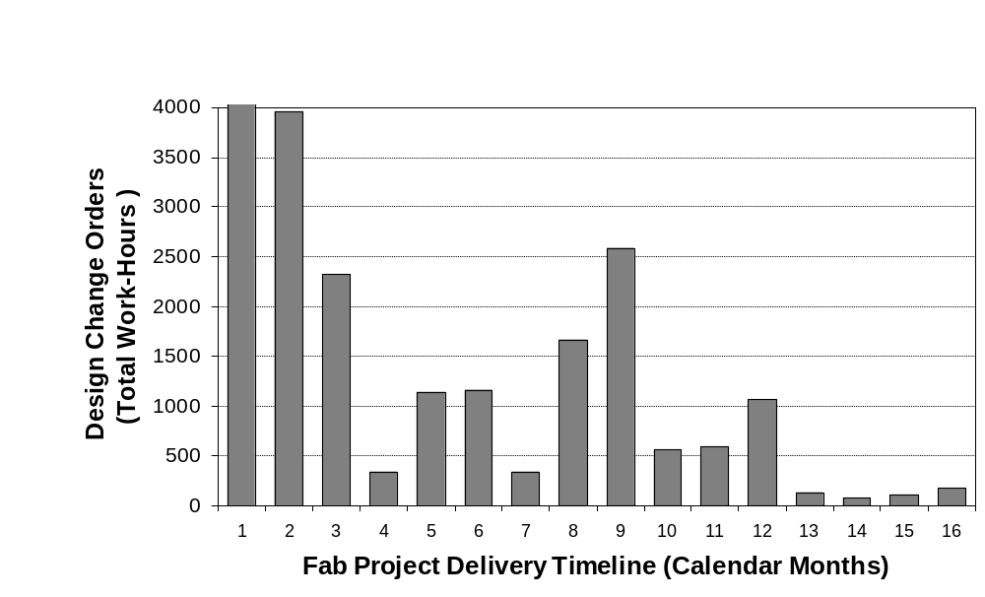

Headquartered in Denver, CH2M HILL Ltd. was a family of companies established in 1974 offering a broad array of services through its subsidiaries to industrial, governmental, and commercial customers. CH2M HILL took projects from concept through planning, financing, design, construction, and operations and maintenance. It was founded in 1946 as a 4-person partnership and had grown to 11,000 employees located on 6 continents; it ranked 10th in construction services in Forbes’ 500 Largest Private Companies and 671st in Fortune 1000.
Semiconductor Industry Association (2000). National Technology Roadmap for Semiconductors: 2000 Update. Factory Integration, TX, SEMANTECH.
This phenomenon showed a U-shaped curve when plotted as a function of yield versus time.
McDonald, C.J. (1998). “The Evolution of Intel’s Copy EXACTLY! Technology Transfer Method,” Intel Technology Journal, Q4’98.
The 300mm-wafer offers 225 percent of the silicon surface area and about 240 percent of the printed die (individual computer chips) per wafer relative to standard 200mm-wafers. Larger wafers are estimated to give a 30% cost advantage over smaller wafers; the next transition from 300 to 450mm-wafers is already lined up to happen around 2014.
IBM pioneered the copper-based technology that made chips just 0.13 micron across, compared with the former technology of 0.18 micron, to overcome resistance problems and create faster chips; a micron ⎯ 1/1,000,000 of a meter ⎯ is approximately 1/100th the width of a typical human hair.
In May 2000, Intel further announced another $2 billion investment (‘construction will begin immediately’) for adding 135,000 sq.ft. of cleanroom space to an existing fab in Rio Rancho, New Mexico, and incorporating 0.13 micron process technology on 300 mm-wafers.

